python-api’s report

Due : Saturday, February 6, 2021 by 12:59 pm | By Melinda Eudy

# Background

Start with Weather API and a random list of cities to research their relationship of Latitude to temperature, humidity, cloudiness and wind speed. Create scatterplots and run liner regress on the relationships.

Next, reduce the list of cities to ideal vacation spots based on temperature between 70 and 80 degrees, wind speed less than 10 mph and zero cloudiness. Next locate a hotel in the city within 5000 meters of the city and plot it on a heatmap.

# Data Used

Used OpenWatherMap Api and Google Maps Platform to create the data for the cities and analyze the data per the given parameters.

# Observable Trends, based on the data provided

1. The closer the city is to the equator the warmer the temperature.

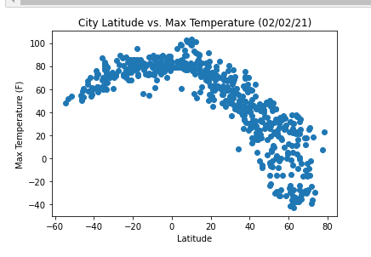

1. There is literally no relationship between cloudiness or wind speed and where the city is located.

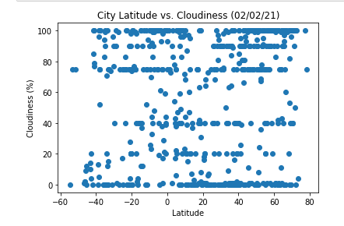

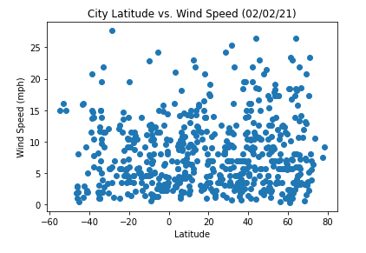

PART II heatmap with pins locating the hotels in the Ideal locations

